Fall Symposium R instructions

Open R

Navigate to the Proc.R file and open it in R

Change the path for ‘home’ from ‘/Users/aidenjohnson…’ to the location of the C:/Username/Rworkshop

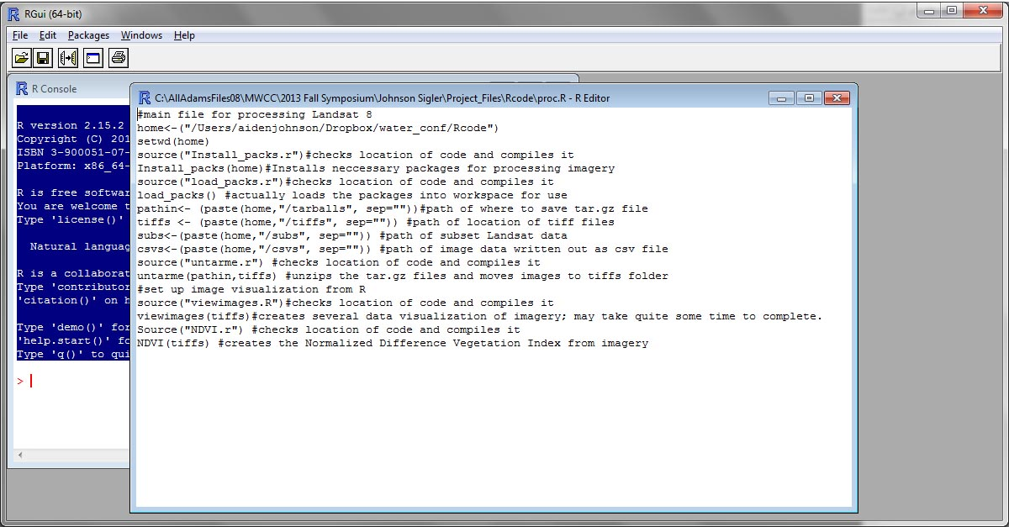

Select

Packages-> Set Cran Mirror

Select ‘USA (CA1)’

Packages->

Select ’raster’